Yours, Lord, is the greatness,
the power, the glory, the splendour, and the majesty; for everything in heaven and on earth is yours.
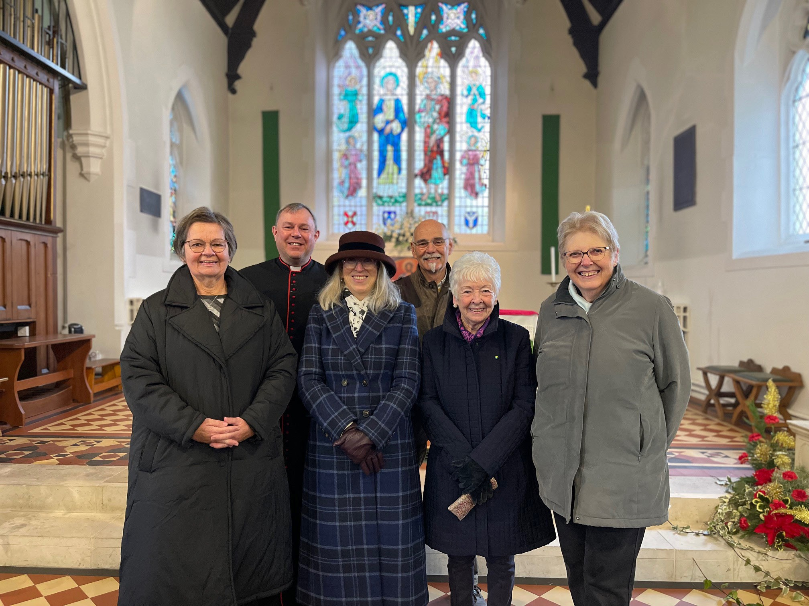
All things come from you, and of your own do we give you.
St John’s Church Higham

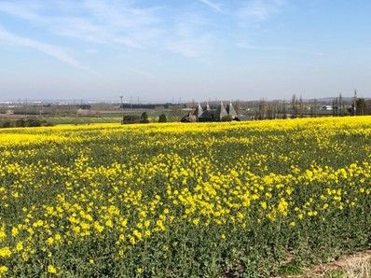
Please make your response using this form and return it to our Stewardship Secretary.

By thinking about your giving and being as generous as you can, you will make a real difference to the finances of our church, and what we can do here, in Higham.

Would you consider leaving a gift in your will to St John’s? This is a practical way of saying ‘thank you’ to God for all the blessings we have enjoyed during our lives. Generous bequests in the past have made
a lasting contribution to many of our Churches and helped secure the work of those parishes for future generations, and many of those
bequests, which are small have made just as big a difference as large ones.

To leave a gift to your church you don’t need to make a
completely new will; an addition to your existing will using a codicil is all you need to do. If you don’t have a will you can make one for free, online at https://farewill.com/cofe

Find more information at: https://www.churchofengland.org/our-faith/church-legacy or call the Legacy Information Line: 08445 870875

Response Form

Thank You

How much should I give?
What you give is up to you. Some people feel they can follow the biblical principle of tithing (committing one tenth of income), however we appreciate that many people are unable to do this. It can be helpful, though, to work out what percentage of your income you give to the church at the moment, and decide whether you can increase the percentage you currently give.
The table below shows what your gift will be at different percentages, if your monthly income is between £850 and £4,800.

Income | £850 | £1,300 | £1,650 | £2,250 | £3,500 | £4,800
2% | £17 | £26 | £33 | £45 | £70 | £96
5% | £43 | £65 | £83 | £113 | £175 | £240
7.5% | £64 | £98 | £124 | £169 | £263 | £360
10% | £85 | £130 | £165 | £225 | £350 | £480

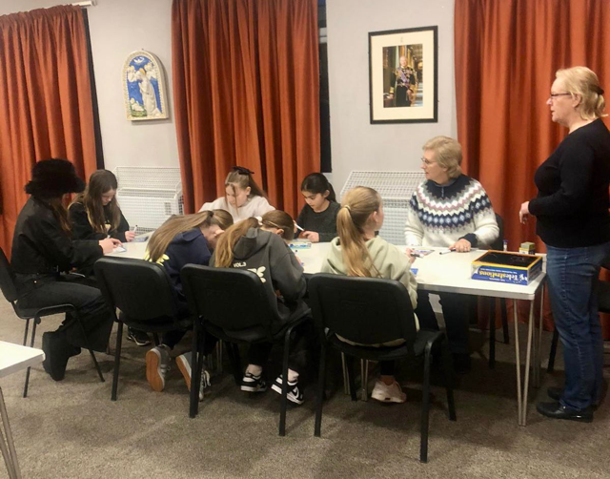

St John’s, Higham
This response is confidential and will be seen only by Cheryl Robins, our stewardship officer.
Your regular giving is vital in supporting your parish church of St John’s, Higham. We are asking everyone in our congregation to review their giving. Please think about, pray about it and decide how much you can give.
Please fill in this form to let us know your intentions and return it whether you plan to make any changes or not, so that we know what we will have when we look at our budgets.
If you would like to set up a new standing order online, or increase your current donation our bank account details are: Higham with Merston Parochial Church Council, Barclays, Sort Code 20-25-42, A/c No 80484733. A standing order form is also enclosed for you to send to your bank if you prefer.
I am new to planned giving and will set up a standing order with a donation of
£ per month/year*
I would like to join planned giving using the envelope scheme, with a donation of
£ per month/year*
I will increase my standing order to £. per month/year*.
I am a UK tax payer and would like to Gift Aid my donation, using the form supplied with this pack.
I would like to make a one-off donation of £ Our bank account details
are as above, or please make cheques payable to Higham with Merston PCC.
I have reviewed my current giving and am unable to change.
*please delete
Name: .................................................................................................................................

Address .............................................................................................................................

........................................................................................... Postcode: ...............................

Tel: ......................................................................................................................................

Email: ...............................................................................................................................

Thank you for your response

