Grand Junction to Work with ISU on School Site Redevelopment Ideas
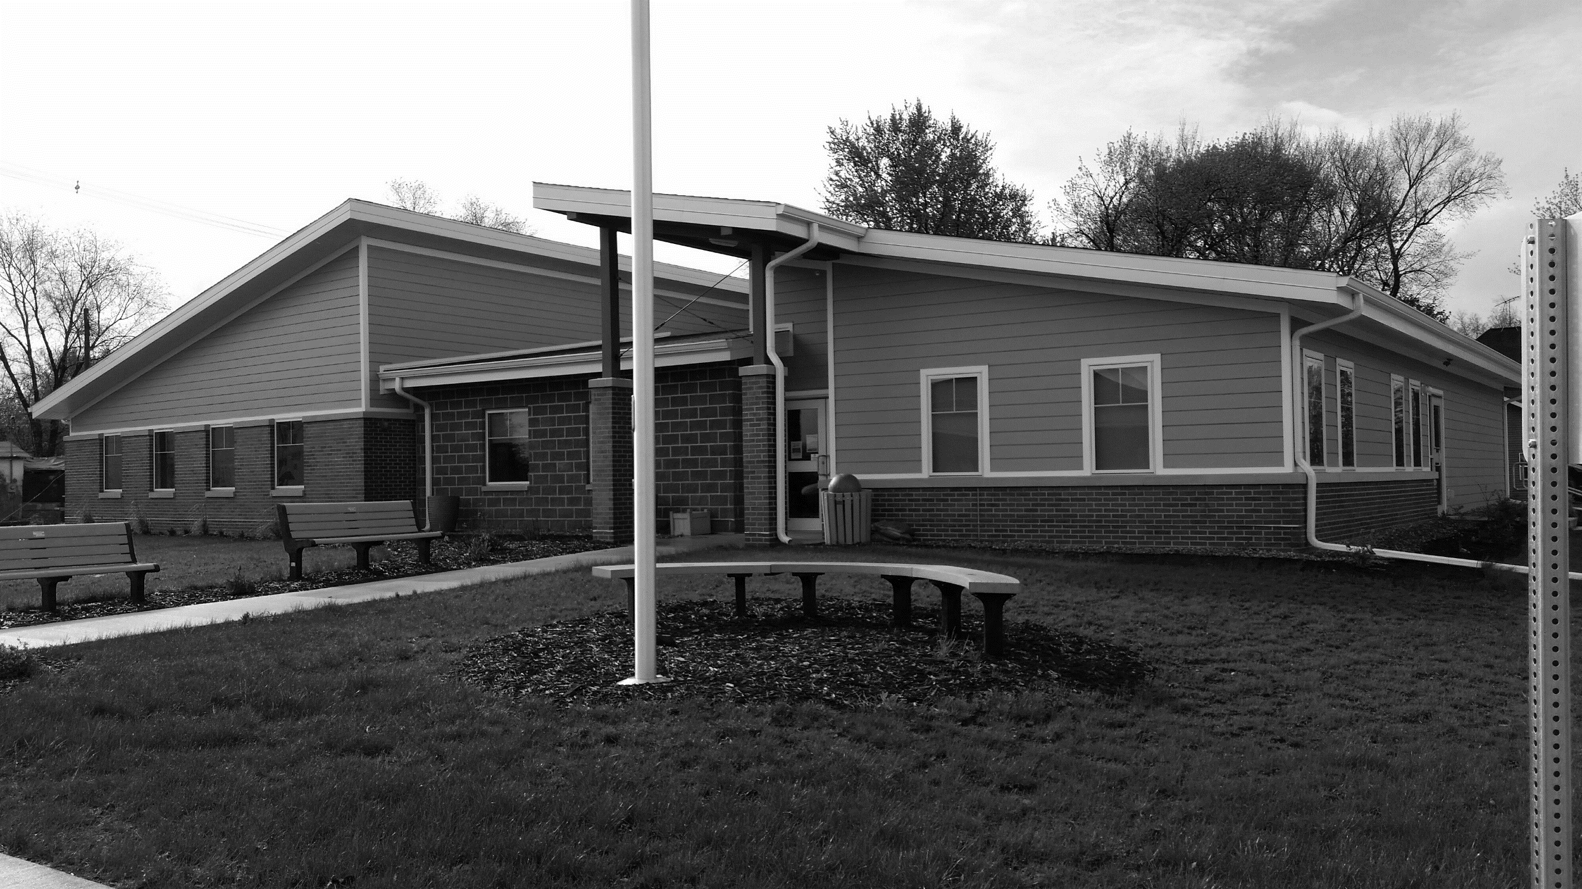
GRAND JUNCTION FALL 2019 NEWSLETTER
The City Council has entered into a design proposal agreement with the Community and Regional Planning department of Iowa State University for ideas for redevelopment of the former Grand Junction school site.
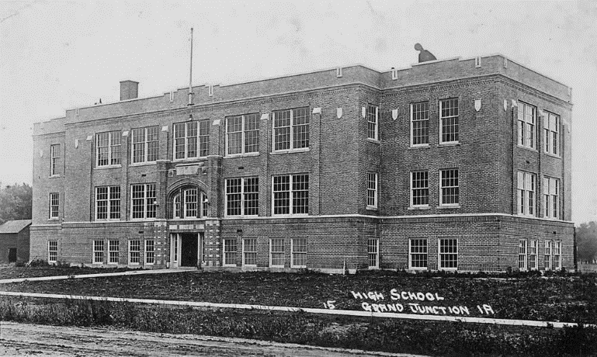Iowa State students, along with Professor Susan Bradbury, will work to produce a series of concept design plans for the property.
Work products related to this project will include
- developing and conducting community-wide citizen participation to provide input regarding recreational uses for the site;
- researching recreational options and costs;
- holding a public meeting to present citizen participation and research results,
- and producing and presenting at least five concept design plans for community consideration.
The project fee of $900, approved in September by the council, will cover transportation, supplies, printing, and copying costs.

The agreement benefits the university by providing students a real-world opportunity for community planning and design and benefits our town by providing redevelopment design concepts at a far lower cost than could otherwise be obtained.
Trunk or Treat Set for Saturday, Oct. 26
The Grand Junction City Council has scheduled the town’s annual Halloween Trunk or Treat Night for Saturday, Oct. 26, from 5:30 to 7 p.m.
This popular and safe Halloween event for kids 12 and under will take place along Main Street in Grand Junction and everyone is invited to join in for a fun evening.
Volunteers are needed to hand out treats. Set up will begin at 5 p.m. You can park your car (decorated if you want!) along the north side of Main Street. Be sure to sign up so we’ll know you are coming. Call 515-738-2585 or email grandjct@iowatelecom.net to register.
The Fire Department will present its Halloween safe house – always a big draw for kids – at the same time as Trunk or Treat.
The Grand Junction Library also will offer free hot dogs, chips, and drinks in the Community Center’s small conference room during the event and the building will be open for bathroom breaks.
Library Seeks Increased Certification, Offers New Photo Printing Service
The Grand Junction library has had an exciting year so far. In addition to sponsoring a breakfast and the Blank Park Zoo during the GJ 150 celebration, the library has featured book discussions led by authors, a sewing group, a “haunted house” for Trunk or Treat, and a well-attended Children’s Summer Reading Program. The library thanks all who participated in these activities, and congratulations go especially to Montana Kiley, winner of the Summer Reading quilt!
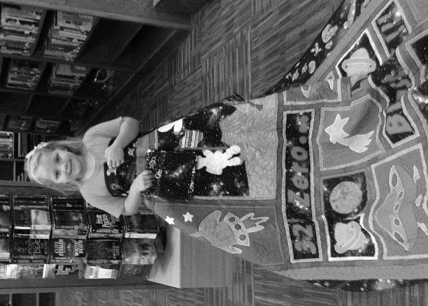
Plus, the library recently received a grant from the State Library of Iowa to acquire a photo printer. For 30 cents a copy, you can now print 4x6-inch photos. Photos can be printed from your smart phone or from a memory card.
Next up the library is seeking to increase its state certification from Level II to Level III. The higher level will involve further training for library personnel and expanded hours to include weekend hours. It also will mean increased stated funding for the library. The strategic planning process to prepare for this higher certification began this month. If you have ideas on how our library can better meet the needs and goals of our community, please contact the librarians or Library Board.
Lincoln Highway Association Salutes Convoy Centennial
More than 50 restored military vehicles rolled through Grand Junction on Aug. 24 on their drive across the nation. That tour was sponsored and organized by the Military Vehicle Preservation Association.
Two weeks later, a caravan of cars, some custom and antique, came through town, stopping for lunch at the Community Center. That tour was sponsored by the Lincoln Highway Association. Both tours commemorated a 1919 U.S. Military Convoy which explored the effectiveness of moving troops and equipment across the country using Highway 30, the Transcontinental Highway.
Road Repair Update
More than 40 blocks of city streets were resurfaced late this summer by Sta-Bilt Construction at a cost of nearly $85,000. Sta-Bilt resurfaced 27 blocks of Grand Junction streets two years ago.
Grand Junction streets suffered more than usual wear and tear this past winter, causing the surface treatment of several streets to break apart. To help alleviate wear and tear on city streets, the council has formed a committee to work on designating specific truck routes throughout the town. The routes will work in conjunction with enforcing the city’s ordinances for load restrictions and truck traffic on our streets.
City Elections Scheduled
City elections are held in odd-numbered years on the first Tuesday after the first Monday in November. The 2019 Regular City Election will be held on Tuesday, Nov. 5.
Grand Junction will elect a Mayor for a two-year term and two City Council members, each for a four-year term.
Compliance Officer Thank-You
Rick Scheuermann, the new GJ Compliance Officer, says he is grateful to everyone for their cooperation and help as he undertakes this job. He writes:
“I would like to thank all of the people of Grand Junction that I have met since I have begun my duties as Compliance Officer. The cooperation with my office has been very gratifying and the progress that is occurring with clean-up is outstanding. It speaks well of the pride each person takes in this community. You all have made my job easier with the cooperation and ideas you have given me.
“I especially enjoy the conversations and the stories I have received during my travels around town. The feeling of community pride is evident with every person I meet and I am proud to serve you and this community. I want you to know how much I appreciate your help and your commitment to Grand Junction.”
Peoples Bank Again Sponsors Free Swimming Lessons
Peoples Bank sponsored two weeks of free swimming lessons again this summer for youth ages 4 and up. Some 50 children participated in the sessions.
Also, the Beta Tau Delta sorority donated $300 to our pool again this summer. These funds were used toward safety training to enhance lifeguard skills.
Many thanks go to both organizations for their wonderful support of our children and our pool.
New Businesses Planned
At least three new businesses are in the works to open soon in Grand Junction.
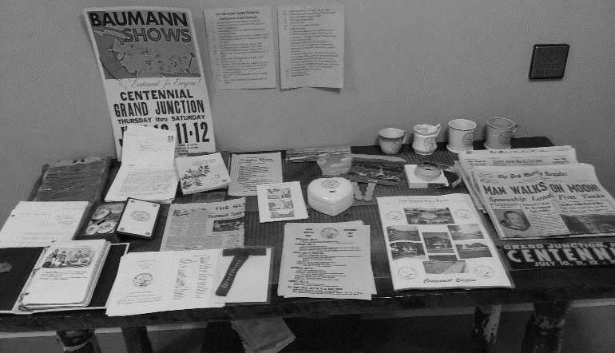
The Coffee Corner at the corner of Main and 12th streets opened temporarily during the GJ 150 celebration and is waiting for its drive-through lane and other details to be completed before a grand re-opening occurs.
A collectibles shop named Purple Cows and Rainbows featuring unique gifts and one-of-a-kind items will open at the corner of Main and 11th streets next to the library.
On Highway 30, the former Ferg’s has been sold to a group of local investors who are renovating the venue to reopen it as a sports bar and grill.
Annual Jingle Into Junction Scheduled for Dec. 8
Circle your calendars for Sunday, Dec. 8, and plan to attend Grand Junction’s annual Jingle Into Junction holiday celebration at the Community Center from 5–7 p.m.
This community get-together is a great way to kick off the holiday season and a fun night for everyone in town to come get in the holiday mood.
2020 Calendars Offered for Sale by Naked Ladies
The Naked Ladies Garden Club has produced a calendar for 2020 featuring full-color photos of our attractive local men pictured with well-dressed Naked Lady flowers.
A great gift idea, the calendars are $15 each and available by calling Jan Scharingson at 515-738-2608.
GJ Celebrates 150 Years With Crowds and Fun
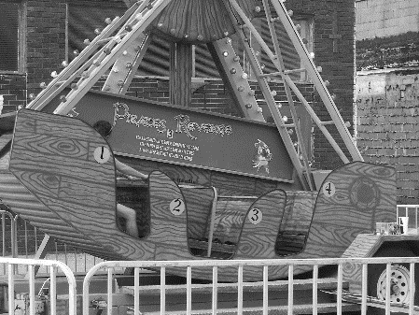
Grand Junction welcomed large crowds and good weather for its 150-year anniversary celebration held Aug. 2, 3, and 4.
An amusement carnival opened on Main Street Thursday for three days. Nearly $2,400 in advance tickets were sold.
The Community Center featured numerous displays, including items from the time capsule that was buried after the town’s centennial in 1969, vintage quilts, and other vintage GJ items.
Ralph Miller put together a slide show of old Grand Junction that also ran continuously during the hours the building was open.
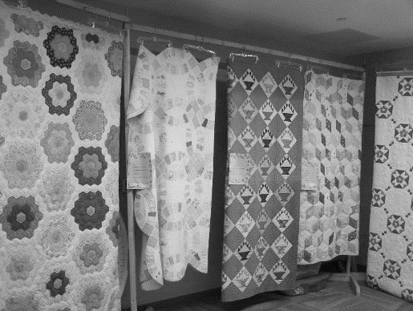
On Friday dozens attended the Greene County Historical Society program on Greene County movie theatres by Mike Piepel in the Community Center. That evening the Off the Track Players performed three short “Reader’s Theatres” plays with musical interludes provided by Sheilah Pound, followed by an ice cream social. The Lincoln Highway and Kennedy museums also were open Friday and Saturday afternoons and enjoyed good attendance.
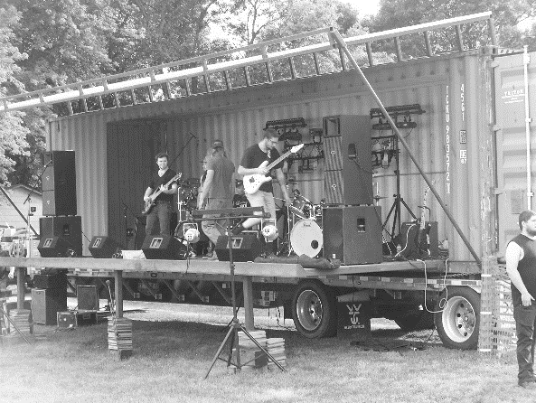
The beverage garden/entertainment venue next door opened at 4 p.m. At 7 p.m. GJ’s own “Through the Darkness” performed to an enthusiastic crowd on an enclosed stage donated by Vaughn Bauer.
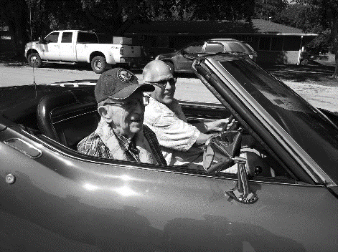
The parade Saturday morning, announced by Travis Graven, featured 60 entries including the Isiserettes dance troupe, which also performed after the parade. Some 2,000 people lined 15th, Hager, and 9th streets to watch the parade led by Parade Marshal Dwight “Red” Mount, GJ’s oldest citizen. Old cars, fire engines, and vehicles of all kinds participated in the parade, and the East Greene Class of 1969 celebrated its 50th-year class reunion with a float in the parade.
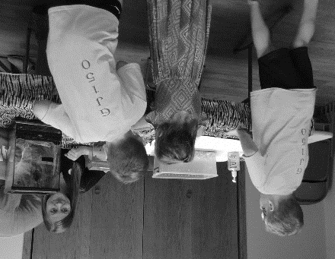
The Lions Club car show at City Park enjoyed a greater turn-out than usual with more cars on display than ever before, and more than 100 people attended the Blank Park Zoo exhibit at the library. Other afternoon activities included a box lunch picnic, artisan fair, the Greene County Singers, kids’ face painting, and kickball and bags tournaments along with the carnival and beverage garden. That evening the Beef Producers provided supper before entertainer Jamie Kelley took the stage before another animated crowd.
Contact City Hall by calling 515-738-2585 or email grandjct@iowatelecom.net.
Office hours are Monday through Friday, 9 am to Noon or by appointment.
www.grandjunctioniowa.org
To receive this newsletter via email, please notify the clerk’s office.
Sunday saw an excellent turn-out for the open golf tournament at Lakeside National Golf Club and a good crowd attended the “Transportation and Transitions” historical program at the Community Center that afternoon.
Contest winners announced by Travis Graven before the parade were:
Beard contest winners: Tom Horn (longest); Haven Frantz (thickest); Harold Osterman (People’s Choice)
Pie contest winners: Fran Teagarden, 1st; Diane Ostrander, 2nd; Jan Scharingson, 3rd
Trivia contest winner: Claudia Light
Families with most generations still living in GJ (all with 4): Phyllis Gannon; Janice Gilley; Wilma Herrick; Keith Hoskinson; Johnette Kellogg; Leo & Blanche Kersey; Ramona Kersey; Jean Moranville; and Harold Osterman
The town received many positive comments about its festivities and thanks all who planned, helped, and participated in making Grand Junction’s celebration of 150 years such a success!
New Time Capsule to Be Buried
Please plan to join us at the Community Center on Saturday, Oct. 26 at 3 p.m. for a program of stories and artifacts of Grand Junction’s history presented by Dale Higgins.
Afterwards we will bury a new time capsule – containing items from the old time capsule as well as items from today – outside the library
Following that will be a community cookout for all to enjoy before the Halloween fun of Trunk or Treat begins at 5:30 p.m.

