We don't need to check this list twice...
As your Congresswoman, here are 19 BIG WINS I proudly secured for you and communities throughout Maine's 1st district just this month:
- $5 million to aid farmers impacted by PFAS "forever chemical" contamination. While Maine has led the nation in testing and responding to PFAS contamination on farmland, there is no question that farmers in other states will be affected. More aid will be needed but this is a critical first step to support Maine farmers grappling with this crisis.
- After years of advocacy, the York River will now officially be designated as ‘Wild & Scenic’. The designation opens communities along the York River to new technical assistance and federal funding, and provides a local forum for the watershed communities to collaboratively address the river's long-term stewardship needs.
- Acting together, Governor Mills and our bipartisan congressional delegation secured a lifeline for Maine’s lobster industry by enacting a regulatory pause on misguided federal regulations.
- $45 million in long-awaited funding to address severe erosion at Camp Ellis. Camp Ellis and the surrounding Saco community have endured an extremely long wait for this funding. For 14 years, my staff and I have worked with the City of Saco and the residents of Camp Ellis to shore-up this beloved area.
As a senior member of the House Appropriations Committee, I also proudly secured direct funding for 15 projects totaling $34.5 Million in Maine’s 1st District. These projects include:
- $500,000 for the Alfond Youth Center in Waterville for targeted support to children and families in need
- $535,000 for Amistad in Portland for supportive recovery housing
- $750,000 for Apex Youth Connection in Biddeford for its youth job readiness center focused on at-risk youth
- $12,326,000 for Bigelow Laboratory in East Boothbay for its new Ocean Sciences Innovation and Education Wing
- $3 million for the Maine Irish Heritage Center in Portland for building restoration
- $1 million for the Central Lincoln County YMCA Child Care Center in Damariscotta in for renovations and expansion
- $3,452,978 for the City of Saco for its water resource resilience project
- $3 million for the Goodall Memorial Library in Sanford for renovations and expansion
- $2,105,000 for the Knox Clinic in Rockland for construction and outfitting of a new facility
- $1 million for Northern Light Mercy Hospital in Portland for language acquisition and health care workforce training
- $1 million for the Preble Street Food Security Hub in South Portland to support its anti-hunger work
- $2,750,000 for the Governor’s Energy Office for energy efficiency workforce training and support
- $1 million for the Town of Limerick for its water and sewer mains replacement project
- $1,500,000 for Boots2Roots in Portland for its veteran-focused transition to work initiative
- $619,000 for the Greater Portland Immigrant Welcome Center for a new women’s entrepreneurship program
Thanks to all of you for helping to make this year one to celebrate.
Have a happy and healthy holiday and New Year!
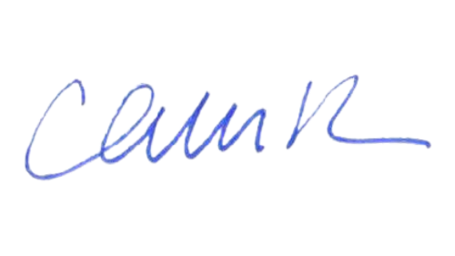
Chellie Pingree

