Chapter 3
Working with Customers
Name: ______________________________
Class: ______________________________
Date: ______________________________
- What happens when you click this link?
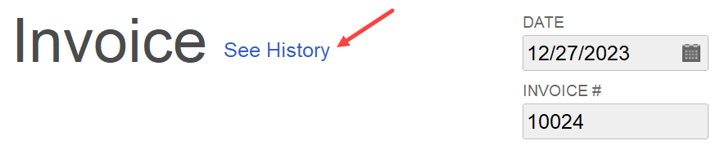
- The Invoice History window opens
- The Historical Transaction window opens
- The Invoice Details window opens
- A Customer History report is created
- If there are no payment terms indicated on the invoice, the due date will be in:
- 5 days
- 10 days
- 20 days
- 30 days
- What report type shows all transactions recorded in QuickBooks for a particular center list entry or account?
- Balance Sheet
- Profit & Loss
- Sales by Item
- QuickReport
- Which “behind-the-scenes” images show what happens when you create an invoice?
- 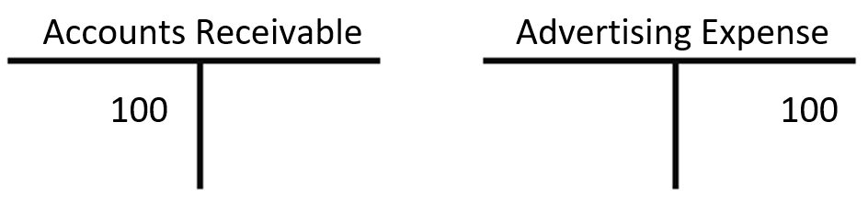
- 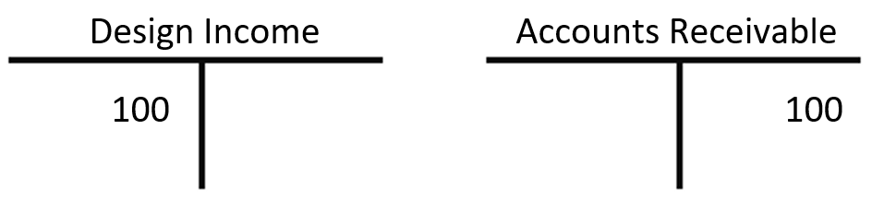
- 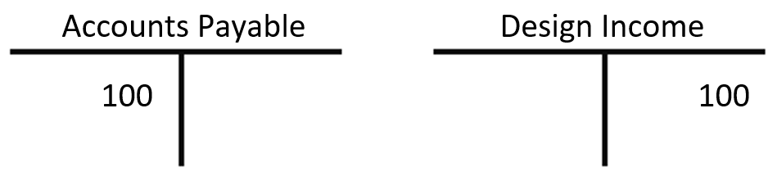
- 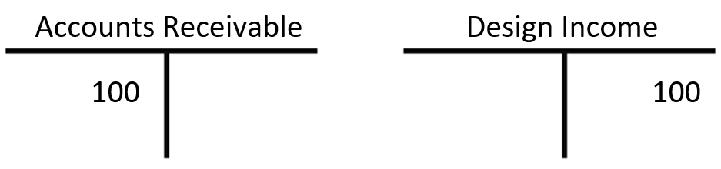

- Which Home Page task icon do you click to enter a customer sale “on account”?
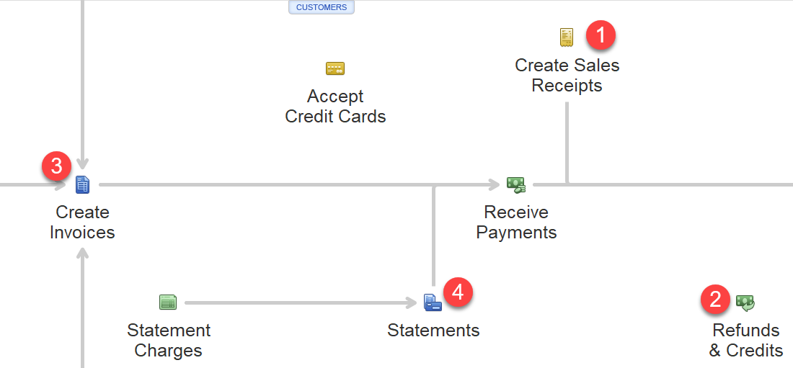
- 1
- 2
- 3
- 4
- What sales form do you choose if you don’t want Accounts Receivable affected?
- Invoice
- Sales Receipt
- Statement
- Receive Payment
- Which feature lets you search the entire company file for a menu command?
- Simple Find
- Find Menu
- Search
- Advanced Find
- Before you can add something to an invoice, the item must be created as a(n):
- service
- inventory
- item
- company
- What must you specify when creating an invoice?
- Vendor
- Transaction
- Customer
- Service
- Carlos has many customers in his company file. To improve navigation, he wants to clean up his customer list by removing those he’s pretty sure won’t be coming in again. What’s the most efficient way for Carlos to do this?
- Delete the unwanted customers.
- Put an asterisk (*) before the unwanted customer names.
- Edit the unwanted customer names to the names of new customers.
- Mark the unwanted customers as inactive.
- What happens behind the scenes if you don’t use the Receive Payments window to record a payment on an invoice?
- Income will be understated, and Accounts Receivable will be cleared out.
- Income will be overstated, and Accounts Receivable will be cleared out.
- Income will be understated, and Accounts Receivable will not be cleared out.
- Income will be overstated, and Accounts Receivable will not be cleared out.
- To remove a transaction and still retain a record of it, use the _____ command.
- Edit
- Correct
- Delete
- Void
- Which list is integrated into the Customer Center?
- Item List
- Customer Type List
- Customers & Jobs List
- Customer Reports List
- When can you add a new customer or job to the Customer Center?
- At any time
- During the company setup process
- Only when a previous job is not in process
- Only when you have received all payments from previous customer jobs

- Jemal is creating an invoice, but in the Customer:Job list field, only “<Add New>” is showing. How can he populate the customer list?
- He must finish creating his Chart of Accounts.
- He must enter his customers into the Customers & Jobs List.
- He must restore his Item List.
- He must finish the company file setup process.
- Kendall is encouraged by her number of repeat customers and wants to begin tracking the profitability for each project she completes per customer. What should she set up to track this information?
- Jobs
- Projects
- Subcustomers
- Items
- Eisa recently added a new customer. After a week of entering transactions for that customer, he realizes he misspelled the customer’s name when he created the record. What should he do?
- Delete all transactions and the customer and then start again from scratch.
- Edit the customer name in the Customer Center, as any changes made to the customer record will change all future and past transactions.
- Go to Company Preferences and execute a Mass Edit.
- Edit each transaction manually.
- When creating a new non-inventory item, what do you do to track both purchase and sales information for it?
- Create a custom field for the item.
- Enable units of measure.
- Indicate that the item is used in assemblies or is purchased for a specific customer:job.
- Enter a note in the New Item window.
- In QuickBooks, what is considered an item?
- Anything the company buys, sells, or resells in the course of business
- Any entry of a vendor, customer, or employee
- Any changes made within preferences windows
- Any entry that appears on a report
- Kyle’s Item List includes many items for cleaning services. Because they start with different letters, they don’t appear together in the list, and he must scroll to add multiple services to an invoice. How can Kyle make finding his cleaning services items easier?
- He can put numbers in front of each item to make them easier to sort.
- He can change the name of each individual item.
- He can group them into subitems under a general term.
- He must continue to scroll; item names cannot be changed.
- When you enter a sales receipt, where do the funds go?
- Accounts Receivable
- Sales
- Deposited Funds
- Undeposited Funds
- Dardean doesn’t want to type in the price for each item she sells on an invoice or sales receipt. What should she do when setting up service items to ensure the prices fill in on sales forms?
- Enter a rate in the New Item window.
- Edit the invoice template to include the rate information.
- Enter a price on the Additional Info tab for each customer.
- Create a Special Rate service item.
- Nick is confused about the different name lists in QuickBooks. Who, exactly, should be entered in the Customers & Jobs List in the Customer Center?
- Anyone to whom he pays funds
- All subcontractors with whom he works
- Anyone who buys or pays for the services or products that his business sells or provides
- Individuals to whom he issues paychecks
- Kelsey is an attorney who invoices for one type of service (Legal Service Fees), adding a custom description for each customer. How does she set this up in QuickBooks?
- She creates a separate service item for each customer in the Item List.
- She sets the service item up in the Preferences window.
- She sets up the new item on the Additional Info tab for each customer.
- She creates one service item in the Item List and leaves the Description field blank.
- Match each form type to its description.
FORM TYPES |  | DESCRIPTIONS
- Invoice  - Sales Receipt | _____  _____ | - Used to gather customer charges for a specific period
- Statement | _____ | - Used when a customer does not pay at the time of service
 |  | - Used when a customer makes a payment at the time of service

- Match each item type to its description.
ITEM TYPES |  | DESCRIPTIONS
- Discount  - Inventory Part | _____  _____ | - Records partial remittance at time of sale and reduces total amount owed
- Subtotal  - Sales Tax Item | _____  _____ | - Applies a percentage discount or surcharge to many items
- Payment | _____ | - Services you charge for or purchase
- Service | _____ | - What you purchase, track as inventory, and resell
 |  | - Subtracts a percentage or fixed amount from a total or subtotal
 |  | - Calculates a single sales tax at a specific rate, which you pay to a single tax agency

