The Circuit Writer
Volume 39 Issue 11

What a joy it is to be your pastor! Thank you for all you have done to show your appreciation to me. I am humbled and honored that you have collected funds to help with heating bills this winter. Thank you!
Do you know your bible trivia? I am impressed with the Bible literacy of our youth and grateful to Frances Eldridge for pouring her heart into them.

We had a trip to Autumn Acres hay maze, and the youth had to answer Bible trivia questions to find their way out of the maze. The questions are included in this newsletter. See how you do!!

As we closed out October with a trunk or treat for the community, we look forward to experiencing Christ this holiday season, and sharing Christ with our community! Please make notes on your calendar, plan to attend and by all means invite a friend. It’s the holiday season which is the perfect time to invite someone to church, and maybe that person will discover a life with Christ that they have never known!!

I will never stop giving thanks for you, remembering you in my prayers.

Denna

Monthly & Weekly Church Scheduling
Sunday School & Worship 9:45am & 11:00am
Youth Group Sundays 5:30pm – 7:00 pm
Monterey Hilltop Chorale Mondays at 6:00pm
Civitan Club 3rd Tuesday of each month at 6:00pm
Choir Rehearsal Wednesdays at 6:00pm
Cottage Ministry Friday & Saturday, 9am – Noon
Garden Club 2nd Tuesday of each month at 10:30am

November Worship Leaders
Liturgist Janet Erskine
Ushers Terry & Catherine Harris
Acolytes Children of the Church

A Record of our faithfulness October 2018

OCTOBER FINANCIAL RESULTS (Operating Funds)
10/01/18 BEGINNING BALANCE $12,006.90
TITHES AND OFFERINGS $13,535.09
OPERATING EXPENSES ($14,763.50)
10/31/18 ENDING BALANCE $10,778.49

Happy Thanksgiving
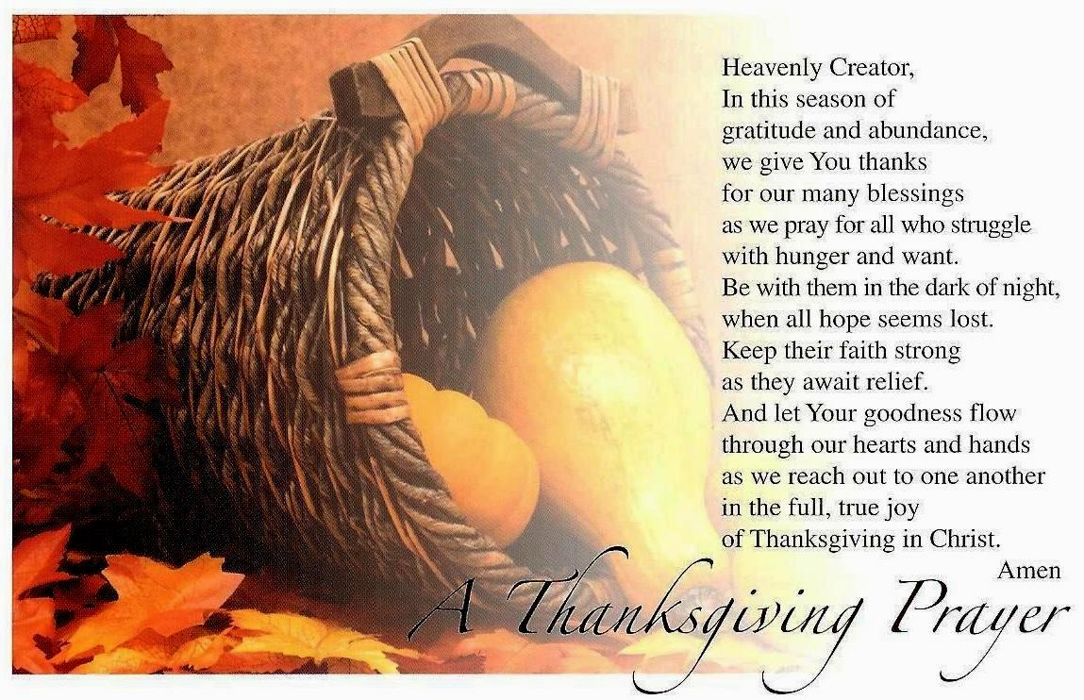

Upcoming Meetings & Events

Are you willing to help prepare youth suppers for approximately 10 youth? Available dates are November 11th, 18th and December 16th

Chorale Concert for Veterans Day – Monday, November 12th at 6pm

Administrative Council Meeting – Tuesday, November 13th @ 6pm

Community Wide Thanksgiving Service – Church of the Nazarene – Wednesday, November 14th at 6 pm

Thanksgiving Open House at the Parsonage and Float Decoration – Saturday, November 24th from 2-4 pm. Come enjoy fellowship together

Youth Ministry: Are you available to help with the youth? We want you! Contact Pastor Denna for more information.

Backpack Ministry: As you are shopping, can you purchase granola bars for the backpack ministry? Leave in the narthex for Judy Webster to pick-up.

Burks Elementary Team: Monterey UMC is an adopter of Burks Elementary. Would you like to be a reading partner? Stay tuned for ways to volunteer and help the students succeed.

MONTEREY’S NOVEMBER BIRTHDAYS

8th – Ray Higgins
9th – John Barwick
10th – Teresa Targosz
12th – Novi Tolley
22nd – Linda Reese
24th = Ed Vail

MONTEREY’S NOVEMBER ANNIVERSARIES

MUMC Wednesdays

5:00pm Early Childhood Music Ministry - FREE music classes for children and a guardian.

An Arrow Pointing to Heaven - Bob Cournoyer will lead a 10-week study of the life and music of Rich Mullins, the forerunner of Contemporary Christian Music. This study will challenge the sensibilities of what it means to follow Jesus in today's world, and build upon his legacy of joy, compassion, brokenness, unblinking honesty, and the wonder of an Awesome God. Coming soon

The Cottage
The cottage has been booming! We have received many great donations and sales were great! There were about 335 people in the last 3 months and 12 families were given food. We were able to make a donation to Monterey High School Project Graduation, such a great event! Several new persons came in and two of those came to church. What a blessing it is to be in this Place! Thank you to all the faithful for food and donations. You make it all possible!
Deborah

Church family,
Your thoughtfulness means so much more than words could ever say.
Much love,
Carol Haney

If you would like to send cards and letters to Lori Mace her address is:

Lori Mace
9707 Almara Drive
Tampa, Fl 33610
Beersheba Springs Christmas Program
We will be going to Beersheba Springs for the Christmas Program on Dec. 6th. We have spaces reserved for 15 people, first come basis. The cost is $18.00 to be paid to the church. Program is 10 a.m. to 2 p.m. with lunch included. This will be a wonderful day of fellowship, prayer and great food. Please contact Deborah Wolfe if you are interested in attending.

Travel Club
We are starting a Travel Club through Common Sense Travel. Wonderful trips with a personal and friendly touch. Big BANG for your buck. Please contact Deborah Wolfe for more information.

Poinsettia Orders
Poinsettias are on sale now. The cost is $8.50 and all orders need to be placed by Saturday, Dec. 1st. There is a signup/order sheet in the hallway. Please place your payment in an offering envelope with your name and Poinsettia
order on the front. Thanks a bunch!!

How Well Do You Know Your Bible?

Are you smarter than a teenager ? Take this short quiz to test your Bible knowledge.

Animals of the Bible

- What animal was the first to be let out of Noah’s ark?
- Dove b. Raven c. Sparrow

- It is easier for this animal to go through the eye of a needle, than for a rich man to enter the kingdom of God.
- Camel b. Dog c. Gnat

- This animal was sacrificed instead of Isaac.
- Ox b. Ram c. Lamb

- In the book of Revelation, Death rides this animal.
- Dark Horse b. White Horse c. Pale Horse

- This animal provided Jesus with money to pay taxes.
- Fish b. Donkey c. Cow

- These were some of the exotic animals that were brought to Solomon.
- Tigers b. Peacocks c. Kangaroos

- These animals fed Elijah during the famine.
- Doves b. Goats c. Ravens

- During the ten plaques, these animals came out of the river Nile.
- Locusts b. Frogs c. Gnats

- The prodigal son would have been happy to eat the food intended for this animal.
- Swine b. Cows c. Sheep

- This judge lit 300 foxes’ tails on fire.
- Gideon b. Samson c. Jephthah

Veterans Day is November 11th.
Please take time to pray for our Military, past and present, and to thank them for all they do to keep our great nation safe.

I would like to take a moment and introduce myself and Thank you all for your wonderful hospitality since I have been here as your secretary. As most of you already know, my name is Ginger Wyatt. I am married to John S. Wyatt and we reside in Grimsley, Tn with our two wonderful children: Camden is 21 and Lexi is 9, and all of our wonderful fur babies. God has blessed us with a wonderful family. If I can be of any help at any time please feel free to call me here at the church or my cell phone number is (931)704-4147. Thank you all again for allowing me to be a part of this wonderful church. God Bless You All.

Red Bird Mission Trip 2018

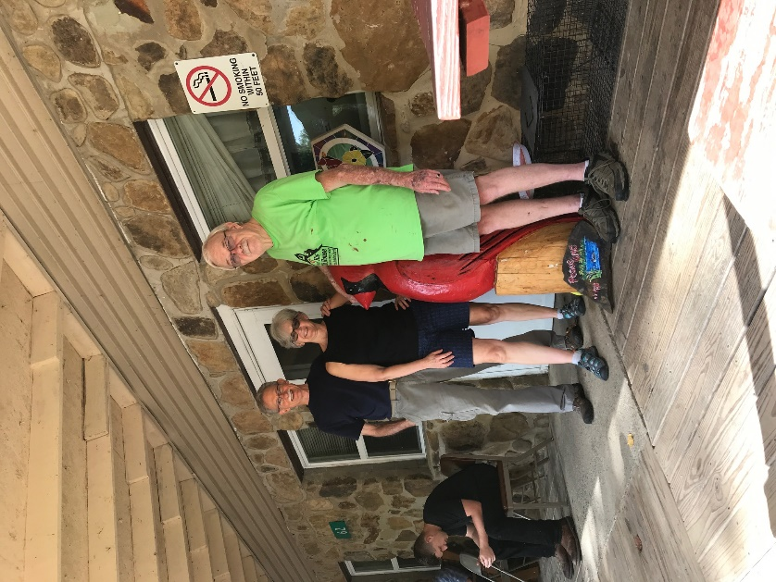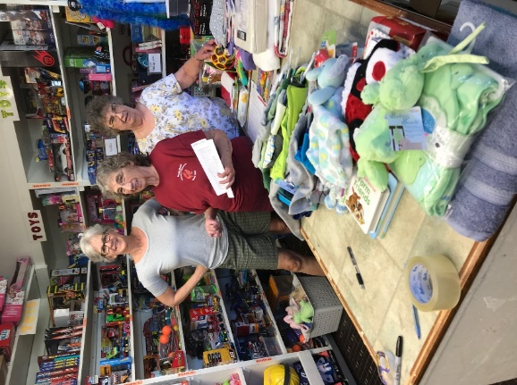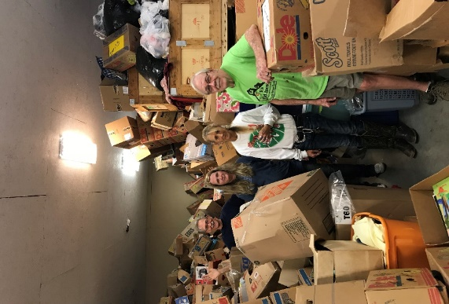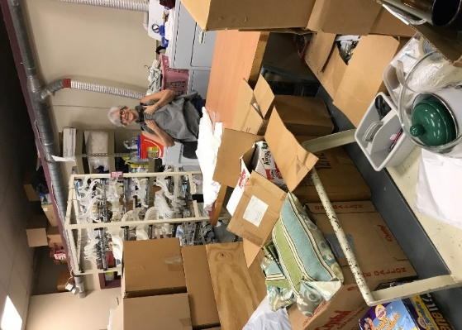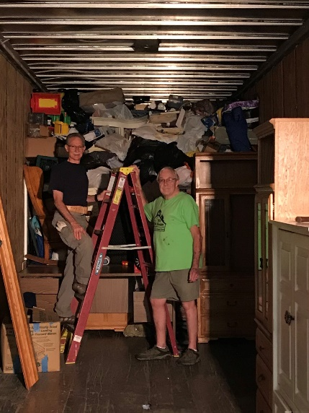

Teens at Autumn Acres
Teens enjoying a wonderful day at Autumn Acres Hay Maze!!

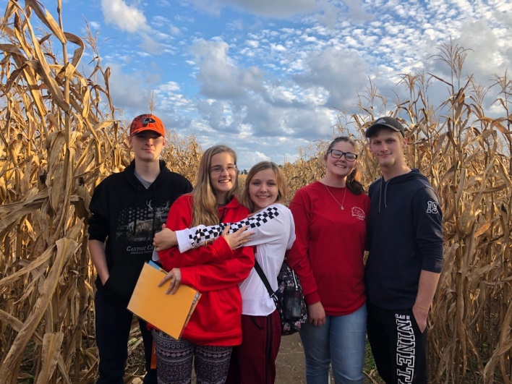

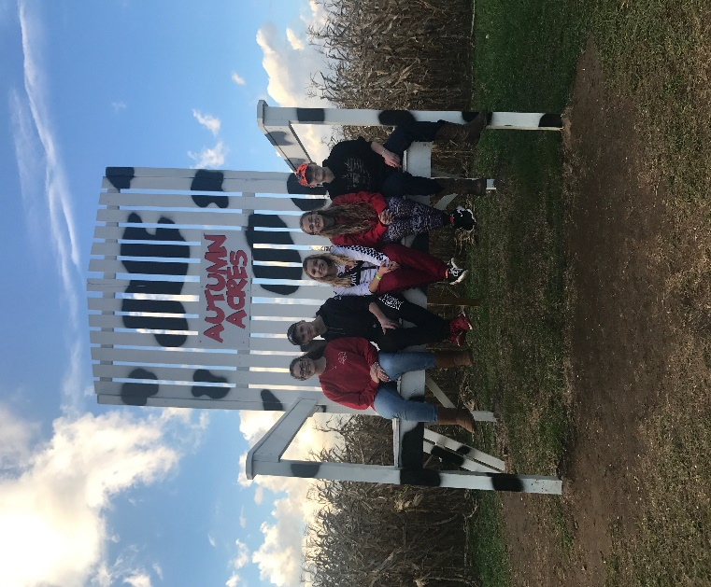

Trunk or Treat 2018
What a wonderful night of fun and fellowship with our community at our annual Trunk or Treat!! Lots of candy and lots of fun! Big THANK YOU to everyone who came and helped make this possible.

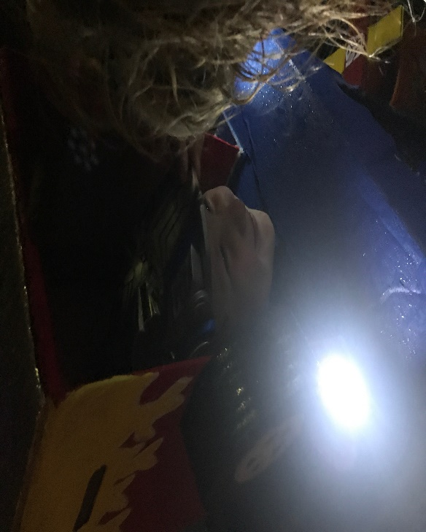

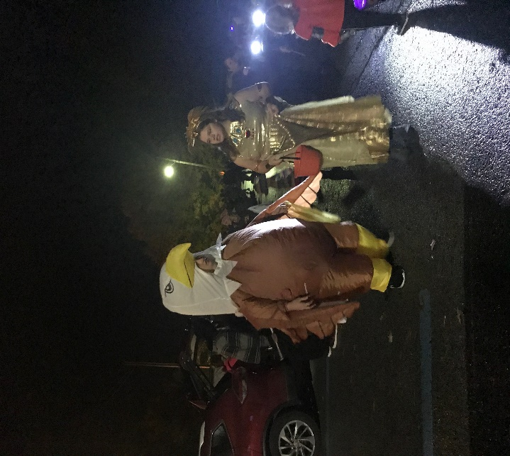

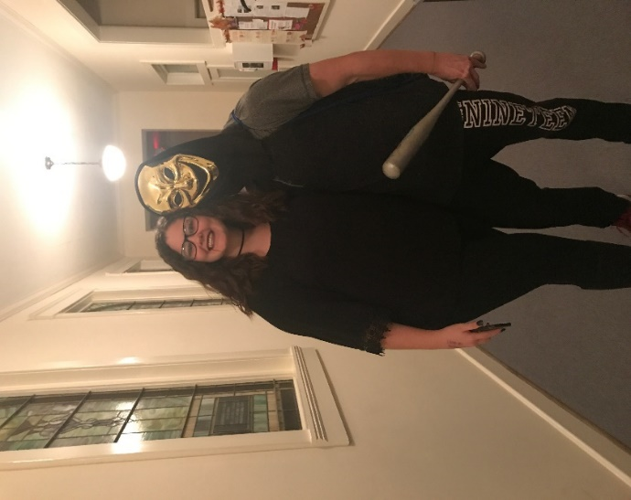

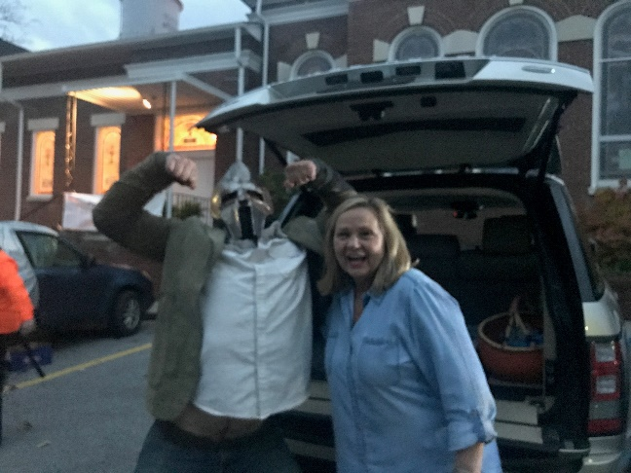

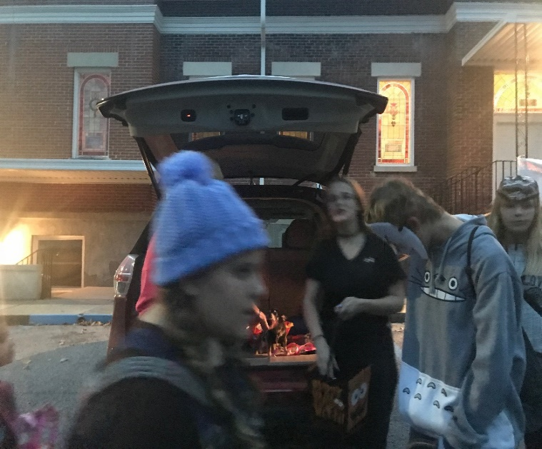

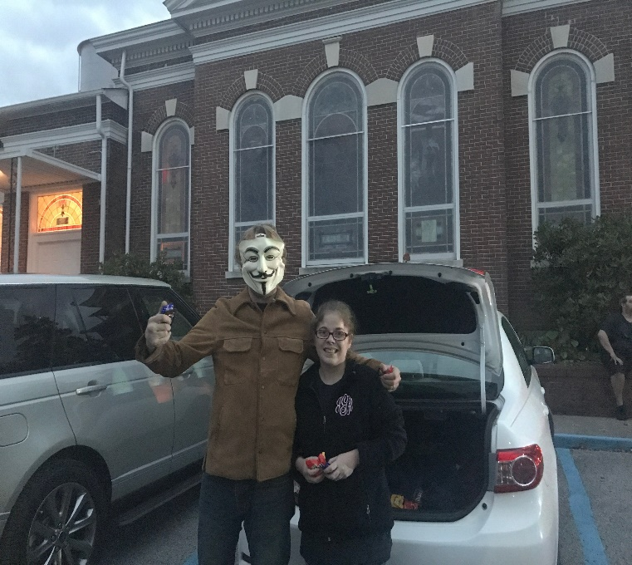

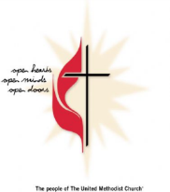
Monterey United Methodist Church
November 2018

Enter his gates with Thanksgiving, and his courts with praise. Give thanks to him, bless his name.
Psalm 100:4
Sun | Mon | Tue | Wed | Thu | Fri | Sat
 |  |  |  | 1 | 2 | 3
 |  |  |  |  | 9:00a-Cottage Ministry | 9:00a Cottage Ministry  Ladies Day Away Before the Holiday Ladies Retreat
4 | 5 | 6 | 7 | 8 | 9 | 10
All Saint Sunday/Communion  9:45a Sunday School  11:00a Worship Service  5:30p Youth Group | 6:00p Monterey Hilltop Chorale |  | 5:00 pm Music for Children  6:30p Choir Practice |  | 9:00a Cottage Ministry | 9:00a Cottage Ministry
11 | 12 | 13 | 14 | 15 | 16 | 17
9:45a Sunday School  11:00a Worship Service  5:30p Youth Group | 6:00p Chorale Concert for Veterans Day | 10:30a Monterey Garden Club  6:00 pm Administrative Council | 6 pm Community Wide Thanksgiving Service at Nazarene Church  5:00 pm Music for Children  6:30p Choir Practice |  | 9:00a Cottage Ministry | 9:00a Cottage Ministry
18 | 19 | 20 | 21 | 22 | 23 | 24
9:45a Sunday School  11:00a Worship Service  5:30p Youth Group | 6:00p Monterey Hilltop Chorale | 6:00p Civitan Club | 5:00 pm Music for Children  6:30p Choir Practice | Thanksgiving | 9:00a Cottage Ministry | 9:00a-Cottage Ministry  2-4 pm – Thanksgiving Open House at Parsonage and Float Decoration
25 | 26 | 27 | 28 | 29 | 30
United Methodist Student Day – Special offering  9:45a Sunday School  11:00a Worship Service  5:30p Youth Group | 6:00p Monterey Hilltop Chorale |  | 5:00 pm Music for Children  6:00 pm Choir Practice |  | 9:00a Cottage Ministry

