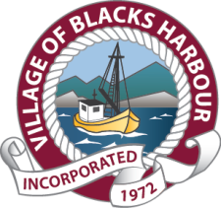
REGULAR COUNCIL MEETING
VILLAGE OF BLACKS HARBOUR
65 WALLACE COVE ROAD
September 21, 2022
6:00 P.M.
AGENDA

1. Call to Order
2. Recording of Attendance
3. Business Arising
4. Approval of Agenda
5. Disclosure of Conflict of Interest on Agenda Items
6. Approval: Council Minutes
6.1 Regular Council Meeting August 17, 2022
7. Staff Reports
7.1 Fire Department Report – August 2022
7.2 Building Inspector’s Report – August 2022
7.3 Public Works Report – August 2022
7.4 CAO’s Report – August 2022/September 2022
7.5 Southwest New Brunswick Service Commission
a) Planning & Development Report
b) Zoning Reviews
8. Accounts
8.1 Budget Figures
8.2 Accounts Payable
9. Reading of Petitions/Presentations/Proclamations
10. Communications – Correspondence, Community Contacts
10.1 Correspondence for Action
- 250 (Saint John) Wing RCAFA Inc.
- Letter to Village of BHS K-2 Team Furniture Fundraising
10.2 Correspondence for Information
11. Approval of Committee Minutes and Recommendations
12. Business arising from minutes
13. Unfinished Business
14. New Business, Motions and Notices of Motion
15. Consideration of By-Laws
- Development incentives
- Property Standards
16. Councillor’s Concerns
17. Question Period
18. Next Meeting/s - Regular Meeting– October 19, 2022 @ 6:30pm
19. Adjournment

