Nathan’s Story
Nathan was born 15 weeks prematurely on January 10, 2004. He weighed less than 2 lbs. and was only 12 inches long at birth. He spent 108 days at Community Hospital, located in Munster, Indiana, in the neonatal intensive care unit. He was discharged in April 2004 with an oxygen tank and heart monitor.

Nathan’s family could not have done it without the support, dedication and compassion of all those involved with his recovery – the doctors, nurses, therapists, special programs and funded research.

“We want to give back to the community” says Philip Splant, father of Nathan.
In his honor, the family founded the Nathan C. Splant Foundation.

Our Mission
The Nathan C. Splant Foundation was founded in 2007 as a public charity foundation 501 (c) (3).

The Nathan C. Splant Foundation is a volunteer-led organization dedicated to helping local families affected by prematurity. Through the Foundation's assistance and grant giving program, we seek to facilitate greater community awareness and improve the conditions of those born too early and too small.

In addition to its commitment to directly helping families, the Foundation also supports prematurity research.
Way’s We are Helping
Prematurity has increased at an alarming rate over the past two decades. Premature births (defines as birth before 37 completed week's gestation) are costly and is the leading cause of death in the first month of life.

Every year, 543,000 babies - one out of eight - are born prematurely. Babies who survive an early birth face serious lifelong health problems, including learning disabilities, cerebral palsy, blindness, hearing loss and other chronic conditions, including asthma.

Donations allow the Foundation to achieve its goal and provide assistance to give families a greater opportunity to devote as much attention as possible to the survival and health of their babies:
- Grant Giving Program
- Help pay for advanced medical equipment for the NICU and upon discharge
- Help offset the cost of medical expenses for those in need
- Expand our support to reach NICU families in local hospitals
- Halo Sleepsacks to all premature babies at Community Hospital and St. Anthony’s NICU
- Eye Angel Program at St. Anthony’s Hospital NICU
- Scholarship Program to a senior attending Hanover High School

THE
Nathan C. Splant
FOUNDATION

“helping local children and families”

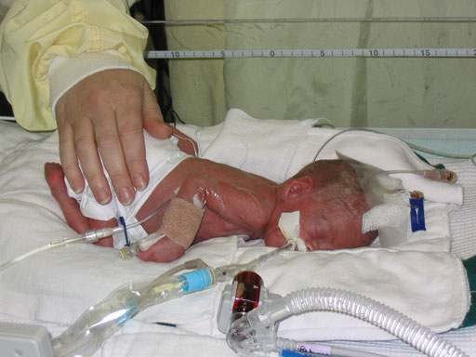

Support for Families
with Premature Babies

Nathan C. Splant Foundation
15500 109th Avenue
Dyer, IN 46311
Phone: 219.365.5800
e-mail: info@ncsplantfoundation.org

www.ncsplantfoundation.org

Way’s YOU Can Help

CELL PHONE DRIVE

Donate your inactive cell phone(s) today! With more than 150 million cell phones retired in the U.S. each year, this program provides the community with a cost-free and convenient recycling opportunity.

PRINTER/TONER DRIVE

Participate in our printer/toner cartridge recycling program by collecting empty cartridges.

If you would like to become a collection point or have a fundraiser through your school, organization or business, please contact the Foundation @ 219-365-5800 or via email: info@ncsplantfoundation.org.

iGIVE.COM

Turn your Online Shopping and Searching into donations! Search and shop for a cause!
www.iGive.com/ncsfoundation


GIVING WORKS PROGRAM
You can help the Foundation in three ways:
- Buy/Sell on eBay
- Donate Items to Sell on eBay
http://donations.ebay.com/charity/charity.jsp?NP_ID=29800
Fundraising Events
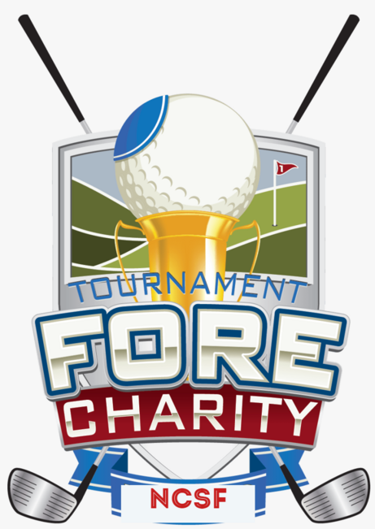

Swing it Forward!

Annual Golf Event


Annual Motorcycle Event

PREMATURITY AWARENESS CAMPAIGN

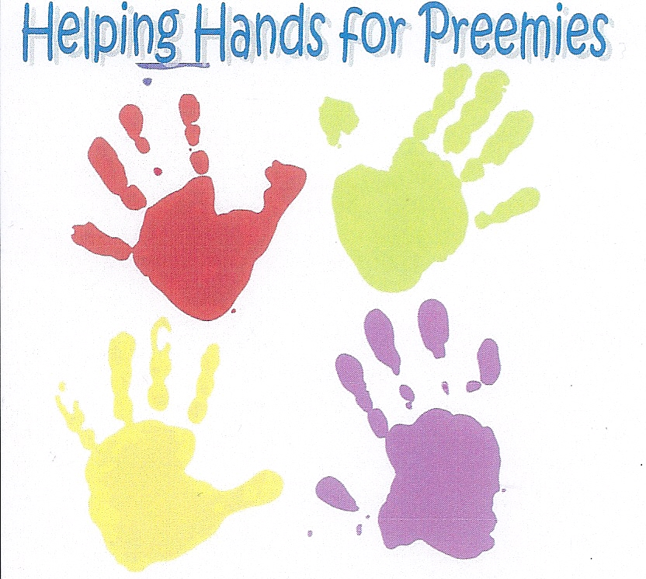

Annual Campaign in November


Senior Attending
Hanover Central High School
Support our Cause

Nathan C. Splant Foundation relies on the generosity of individuals, businesses, corporations and volunteers to support our cause in directly helping premature children and their families.



DONATE
Join us today to make a difference to those born too early and too small. Donations can be made on-line at www.ncsplantfoundation.org or by check/money order (made payable to Nathan C. Splant Foundation).

VOLUNTEER
Volunteers are an important and crucial part to the success of the Nathan C. Splant Foundation and add a valued dimension to our organization. The Foundation is always in need of volunteers. Please call or email us for volunteer opportunities.

The Nathan C. Splant Foundation, is tax exempt under Section 501 (c) (3) (Tax ID #26-0645469) of the Internal Revenue Code. Your donation is tax deductible.

Philip & Kimberly Splant - Founders

