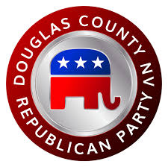
Douglas County Republican Women
Affiliate of The Nevada Federation of Republican Women and
The National Federation of Republican Women

DCRW MEMBERSHIP / RENEWAL FOR 2020

Membership Dues for January 1, 2020– December 31, 2020
(Beginning October 2019, you can renew your membership for 2020)

*$40 Full Member______ **$20 Associate Member______
* Full Members are women who are not already members of another Republican Women’s Club.
** Associate Members are either the spouse of a DCRW member or members of another Republican
Women’s Club.

Your Name_______________________________________ Birthday - Day & Month______________

Husband’s Name_____________________________ Email_________________________________

Mailing Address_______________________________________________________________________

Physical Address______________________________________________________________________

Telephone______________________________________

Please Make Check Payable to DCRW
Mail to: DCRW
P.O. Box 1214
Minden, NV 89423

Treasurer Maxine Rodowicz
Email: max36x@yahoo.com or Phone: 775-600-5759

Our Mailing Address: DCRW
Post Office Box 1214
Minden, NV 89423
Thank you for your continued support of our CLUB!

